

Chapter 1

“And out of the ground the Lord God made to spring up every tree that is pleasant to the sight and good for food. The tree of life was in the midst of the garden, and the tree of the knowledge of good and evil” (Gen 2:9 ESV).

- The Tree
The struggle between right and wrong is an integral part of the human experience, and examination of the Bible shows that God initiates, and often participates in contests (i.e., trials, tests, and challenges) that cause this struggle. In some cases, a person may decide to do the right thing. At other times, people make willful decisions to do wrong. These decisions often have far-reaching consequences. This chapter takes an in-depth look at the first contest recorded in the Bible. To say that the outcome of this contest has far-reaching consequences would be an understatement. We learn from the book of Genesis that the stage was set by God Himself for the contest between Satan and Eve. God placed the “tree of knowledge of good and evil” in the Garden of Eden. The Lord God commanded Adam, saying, “You may freely (unconditionally) eat [the fruit] from every tree of the garden; but [only] from the tree of the knowledge (recognition) of good and evil you shall not eat, otherwise on the day that you eat from it, you shall most certainly die [because of your disobedience]” (Gen 2:16-17). At face value, it would seem that this rule was initiated to fulfill God’s desire to test Adam and Eve’s loyalty and commitment to Him. Let’s take a close look at this first contest established by God and see if we can discover additional reasons that God may have had for this contest.

The First Contest
After creating Adam and placing him in Eden to tend the garden, God initiated the first test in human history. As mentioned above, He placed a certain tree in the Garden of Eden and told Adam to never eat the fruit of that one specific tree (Gen 2:16-17). There were many other plants available for food, and the Eden environment offered a very pleasant lifestyle. Honoring God as the supreme commander of all, and obedience to God’s commands were the prime directives. This sets the rules of engagement for all future contests—obedience is equivalent to love for the Lord. Adam and Eve had direct access to God and were given the opportunity to have a meaningful relationship with God. Unfortunately, they broke the rule, failed the first test (the fall of humankind), and were driven out of the Garden of Eden. At the moment of disobedience to God’s command, sin and death entered the world and the very nature of man was transformed into a Depraved State of being. In the Depraved State, all of humankind from that day forward were born morally corrupt and wicked. In addition, every infant is born in a spiritually blind condition along with the corrupted nature (Original Sin) that is geared toward sin.
In order to highlight the gravity of this moment in Eden when sin entered the world, I want to take a short journey through the entire picture of the Christian belief system and review some essential theological points. There is much more to be said about these topics in later chapters, but I want to note the key points and why these events that occurred in Eden matter so much. Specifically, all people are born condemned to eternal death in hell and ultimately would have ended up in the Lake of Fire if Jesus had not come to pay the price for sin and offer salvation to all. Receiving this salvation requires repentance from sin and belief in Jesus as our Savior. Before proceeding with our study of God’s reason for initiating the fall, let’s take a closer look at Original Sin and God’s rules regarding salvation.
Before creation, God knew that the fall of humankind would happen and He had already designed a plan of salvation—His son, Jesus, would be a sinless sacrifice and the shedding of His blood would redeem humankind from eternal punishment in the Lake of Fire. God had already established the rule that without the shedding of blood there can be no remission of sin. After the fall, additional rules were put in place, and these rules are necessary to bring man back to a full relationship with God that can last for eternity. With God’s assistance, people can be awakened from spiritual darkness and begin the process of controlling their drive toward sin and evil. This is defined as the process of sanctification. The added rules require man to respond to God’s unblinding initiative through repentance and acceptance of the atonement of Jesus Christ on the cross. Man and God work together to improve attitudes and behavior, and to make right choices with newfound Godly wisdom and power. Eventually, after death, every person will be glorified and thereby allowed to be in the direct presence of God. Romans 8:30 states, “And those whom He predestined, He also called; and those whom He called, He also justified [declared free of the guilt of sin]; and those whom He justified, He also glorified [raising them to a heavenly dignity]” (Rom 8:30).
Continuing now with our study of the fall, I think there are some important questions that should be raised regarding this first contest. Why was the Tree of the Knowledge of Good and Evil placed in Eden by God, given that He knew beforehand that the fall would occur? This would be analogous to taking a group of grammar school students to the largest toy store in the world, Hamleys in London, and telling them they can play with any of the toys on all seven floors except one toy in the middle of the first floor they must never touch. Well, knowing human nature, it is certain that the one forbidden toy will eventually become the focus of the students. God knew that Adam and Eve would eventually focus their attention on the one forbidden tree. More importantly, God is omniscient and therefore, He knew that Adam and Eve would sin against Him. So why create this situation in the first place? Before we probe deeper, it was already noted that it would seem this first contest was established by God to test Adam and Eve’s loyalty and obedience to God’s rules. In effect, this contest would determine their true opinion of God. If they viewed God as infinitely trustworthy and absolutely supreme over all people, angels, and worldly things, it would be very unlikely that they would violate His rules. However, we see in the dialogue with the serpent (Satan) that Eve was easily enticed to question the veracity of God’s statements (Gen 3:1-6). This demonstrates that Eve did not have a high esteem for God. But why did she have a low opinion of God given the fact that they knew God and walked with Him in the garden frequently. Now, before we probe further into the reason for Eve’s decision to disobey God, we need to briefly review the four states of human nature because it will give us an insight into Eve’s view of God at the time of the fall. It will also help in understanding God’s plan for humankind in His eternal Kingdom.

Why Did God initiate the fall?
Regarding the Why question, a high-level response is that corruption of human nature is a God-ordained consequence that happened under His will. It was mentioned earlier that God did not want man to eat from the Tree of Life and then live forever in the fallen state. His sovereign plan is to redeem and restore all saved souls to an uncorrupted state of existence in His Kingdom after death. We gain, perhaps, some understanding of the death consequence by noting that we will end up better off by progressing through God’s plan. However, why God initiated the Fall and elected depravity for the human race as a consequence for disobedience is not at all clear. In engineering, when a new process is discovered and not understood, it can be studied by observing its operation to find out the key steps that lead to the final result. This simple phenomenological approach to study of complex systems often gives insight into why the process exists. In the current case, humankind was thrust into a Depraved State as a result of sin. God’s desired steps in the process of restoring humankind are for each individual to encounter God and receive spiritual unblinding by God, admit sins, repent, accept Jesus’ justification, receive the indwelling Spirit of God for eternity, progress through the process of earthly sanctification, die, and receive a resurrected body with a glorified nature so to live in God’s presence and worship Him for eternity.
The end result is a human being created in the image of God, indwelt by the Holy Spirit, who recognizes what they have been saved from. There will be a new and deeper realization of the greatness of our God. We will have the power of the Holy Spirit to maintain obedience and to worship God fully. John Piper has reminded us that, in heaven, we will enter into an ever-deepening praise cycle where God reveals some of Himself, and we praise Him more. Piper states—“Heaven will be a never-ending, ever-increasing discovery of more and more of God's glory with greater and ever-greater joy in him. The perfection of heaven is not static... there will always be more, and the end of increased pleasure in God will never come". In other words, every time God reveals more of His perfection, we delight further in Him and praise Him even more intensely. Since God is infinite, this process will never end and will get bigger and bigger every moment. We will move from one crescendo of praise to another, higher crescendo, throughout eternity. The final result being heaven full of saved souls in deep relationship with God who will never have an intention of rebellion against God. Also present will be the angels who have already demonstrated their allegiance to God by not participating in Satan’s rebellion. I do not know about you, but this sounds like heaven to me. The thought of being in God’s presence and being able to worship him and to speak with Him overwhelms me. Just to be near the King is the greatest thing I can think of. We should desire the King above all, and not the things on the King’s table.
Since the key steps in the process described leads to fulfillment of God’s plan to create humans that interact with Him and fulfill His desire to be praised, we see that the process is needed to produce the desired end result. Adam and Eve in the Neutral State could not avoid sin. However, all saved people who go through the salvation process will never forget God’s grace and will never rebel. It seems that we cannot appreciate God the way we should without knowing His forgiveness and what we have been saved from (the eternal Lake of Fire). We will live eternally in the final glorified state and indwelt by the Holy Spirit. I believe that God’s Kingdom, in its final state, is the comprehensive answer to the question, “Why did God initiate the fall?”

Chapter 8

“In the beginning God created [by forming from nothing] the heavens and the earth” (Gen 1:1).

8. The Worldview Contest
Simply stated, a worldview consists of our philosophy of life, or our conception of the world. It is a collection of personal attitudes and expectations about the world. It informs our thoughts about life and the actions we take. Worldview may be formulated and expressed in moral decisions, ethics, religion, cultural norms, and scientific beliefs, to name a few. We formulate and modify our individual worldview as we progress through life. It can be argued that an important issue in any person's life is the formulation of their worldview. This is of high importance because our worldview guides and directs everything else in our lives. It is the basis on which we make decisions, interact with the world around us, and how we think.
Up to this point in the book, we have considered several biblical contests, starting with Adam and Eve, and we included several OT and NT case studies. In all of these cases, the contests were waged largely within, and/or around, individuals. This is also true for the contests we considered in subsequent chapters which examined key theological issues related to salvation. We did not discuss it at the time, but the individual’s responses to trials and contests were guided by each person’s worldview. In many cases, the individual’s worldview was radically altered as a result of interaction with the living God. Examples include the transformation that occurred in the life of Peter after his betrayal of Jesus, the change in Saul after his encounter with Jesus on the road to Damascus, and the changes in Moses after the burning bush encounter.
When we looked at the concept of free will, it was concluded that post-Fall humans need the movement of the Holy Spirit to be able to perceive spiritual truth. This event will always change a person’s worldview. For example, we closely examined Saul’s contest with Jesus at the time of his conversion. Up to the time of Saul’s encounter with Jesus on the road to Damascus, his worldview was aligned with that of the Jewish leaders. Saul’s pre-Jesus worldview led him to persecute Christians in an attempt to put down the new Christian movement. After his encounter with Jesus and the subsequent spiritual unblinding, Saul’s worldview was radically changed, and he lived the rest of his life serving Jesus in accordance with His plan to build the church.
We are now moving on to a broader contest that is relevant to nearly everyone alive today. It is perhaps one of the most fundamental worldview questions, and most people ask this question at some time in their lives—“Where did the universe come from?” Questions pertaining to the origin of the universe are very important because the conclusions that are drawn significantly affect our worldview on nearly every topic. If, for example, one concludes that the cosmos came into existence by chance, then there would be no desire to search for an ultimate truth to govern human behavior—life would, by definition, be meaningless under this worldview, and no moral law could ever be claimed to be absolute. On the other hand, if the conclusion is that a loving God created the cosmos, then we would logically seek ultimate truth from God, and this truth would provide moral guidance for living. Further, for the Christian, study of the origin of life and the cosmos is paramount because the Bible places great importance on it. Psalm 104 is a hymn of praise and meditation on God’s creative glory. This Psalm structures its praise chorus based on the six days of creation that are defined in Genesis 1. Several other reasons why Christians should carefully examine the doctrine of creation are enumerated by Erickson: it has played a significant role in the church’s faith, it has an important effect on other doctrines, it differentiates Christianity from other worldviews, it is a point of dialogue with natural science, and it can be the cause for disagreements among Christians.
Nearly all modern-day Christians have been confronted with the spiritual contest related to the question of the origin of the universe. This contest began over 150 years ago with Darwin’s publication of The Origin of Species, and the subsequent introduction of the theory of evolution. Prior to that time, it was widely believed that the universe was created by the God. There were also creation myths from other world religions, such as the ancient Egyptian creation myths. Across multiple worldviews, the origins of life were largely believed to have been initiated by a god which possessed supernatural power. It was not until Darwin proposed the theory of evolution by natural selection to explain the origin of life, and early 20th century scientists proposed Big Bang theory to explain the origin of matter, that non-god-based alternatives were available. It is difficult for an atheist to argue that there is no god if he cannot explain the origin of the universe without involving a god. Looking back over the past 150 years, it is apparent that the development of science and technology was accompanied by a widespread rejection of God with a simultaneous alignment with evolution/big bang theory as the explanation for the origin of matter and life. I argue that these theories have created a spiritual contest. The extent of secularism at modern-day colleges and universities, along with hostility toward engineers and scientists that are serious Christians or Jews, is so pervasive that there should be little question that a spiritual battle is in progress. All too often, the faculty of U.S. colleges and universities look down on colleagues of faith, as if their faith and relationship with God is foolish and naïve. I experienced this treatment firsthand during my employment as an associate professor of nuclear engineering at a Big Ten university.
Both creation and evolution/big bang theories are based on massive assumptions. No one was around at the moment when matter came into existence. So, both theories require faith. I want to repeat that for emphasis—both creation and evolution theories require faith. Both are based on scientific principles to some extent. The question that will be addressed is which of the two theories is consistent with modern science. To do this, it will be necessary to look at data and principles of science and engineering. We will start with Darwin and examine the influences on him that affected his thinking and his theory of evolution. Then we will discuss how the 1980 Mount (Mt.) St. Helens volcanic eruption supports a creationist view. Finally, we will delve into two scientific laws that help us to see that evolution theory is based on assumptions that cannot be supported by science. Although this chapter is rooted in two fundamental scientific principles, and I recognize that most readers do not have a science background, I invite you to press into it. My intent was to make the presentation of this chapter both interesting and informative for the non-scientist/non-engineer reader.

The Universality of the Laws of Thermodynamics
It may appear at first that the field of thermodynamics is a specialized field with little significance to the issues of cosmogony. However, the concepts and laws of thermodynamics embrace all scientific processes in all disciplines. Thus, the concepts of thermodynamics are central to the issues at hand. Thermodynamics came into widespread use at the beginning of the industrial revolution. Its early applications focused on the conversion of heat into mechanical work as the first steam engines were invented. The scientific principles used to quantify the conversion of heat into work were called the principles of thermodynamics. The word thermodynamics was coined from two Greek words meaning “heat power”. As scientific and engineering investigation continued, the principles of thermodynamics were applied in other fields where sources of power could be converted into work.
The first law of thermodynamics is considered to be synonymous with the law of conservation of energy. In thermodynamics, work (or energy) is the product of a force and the distance over which that force operates. So, in layman’s terms, the first law of thermodynamics states that energy cannot be created or destroyed, only converted between forms (like heat and work). For example, an electric kettle converts electricity into hot water, but the total energy in that process remains constant. Or our bodies use food’s chemical energy to be able to move and function—energy is merely changing forms with the total energy being conserved.
Similarly, the second law of thermodynamics has been expressed in several equivalent ways. As defined in the second law, the entropy of the universe is ever increasing. Entropy is the thermodynamic measure of useless energy in a working system, or it can be thought of as the disorder in an ordered system. Isaac Asimov has suggested three common definitions of entropy for physical systems:
1. as a measure of the increasing unavailability of the energy of the system for useful work (classical thermodynamics).
2. as a measure of the increasing disorder, randomness, or probability of the arrangement of the components of the system (statistical thermodynamics).
3. As a measure of the increasingly confused information in the transmission of the coded message through a system (informational thermodynamics).” .
Once again, in layman’s terms, the second law of thermodynamics states that the world is tending toward greater disorder. For example, a barn will become dilapidated over time, not improve itself over time. Or, your cup of coffee will cool over time dispersing that heat into the room around it, but the room heat does not spontaneously make your coffee hotter.
With the definitions of the first and second laws, we can apply these scientific principles to understand the implications of the two laws in governing natural processes. Referring to Figure 8-9, the first law of thermodynamics states that the total energy of the universe is a constant. This is indicated in Figure 8-9 as the
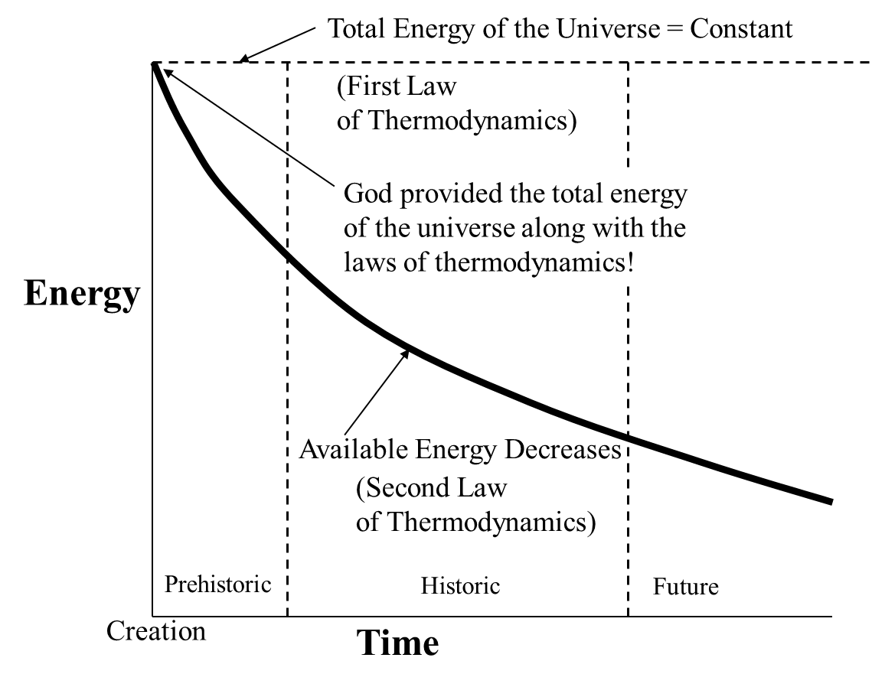
Figure 8-9 Model showing the application of the laws of thermodynamics to all natural processes. The total energy in the universe is a constant (first law of thermodynamics). The available energy in the universe is ever decreasing (second law of thermodynamics). At any given time, the sum of the available energy plus the unavailable energy (used up energy) = the total energy at the moment of creation, which is a constant for all time.
horizontal dotted line at the top of the plot. The creationist holds that God provided this fixed and enormous amount of energy at creation. None of the energy of the universe is now being created. An important implication of this fact is that the universe could not have created itself.
The second law states that the available energy of the universe is continuously decreasing, which indicates that at some past point in time, all of the energy of the universe was available and was perfectly organized. The decrease in the available energy of the universe is shown schematically in Figure 8-9 as the heavy negative slope line in the figure. From the time of creation, the available energy of the universe has been continuously decreasing (entropy and disorder increases), but the total energy of the universe (sum of the available and unavailable) at any time is constant. As noted in Figure 8-9, at any given time, the following equation holds:

Available Energy + Unavailable Energy = Total Constant Energy of the Universe.
The model shown in Figure 8-9 is consistent with the laws of thermodynamics and with the creation account given in the Bible. The Bible does present statements, although not in modern scientific terms, which affirm the laws of thermodynamics. In Gen 2:1-3 (NKJV), we see biblical affirmation of the first law in terms of the universe being finished:
“Thus, the heavens and the earth, and all the host of them, were finished. And on the seventh day God ended His work which He had done, and He rested on the seventh day from all His work which He had done. Then God blessed the seventh day and sanctified it, because in it He rested from all His work which God had created and made.”
We see evidence of the second law in Gen 3:17-19 (NKJV):
“Then to Adam He said, “Because you have heeded the voice of your wife, and have eaten from the tree of which I commanded you, saying, ‘You shall not eat of it’: ‘Cursed is the ground for your sake; In toil you shall eat of it all the days of your life. Both thorns and thistles it shall bring forth for you, and you shall eat the herb of the field. In the sweat of your face you shall eat bread till you return to the ground, for out of it you were taken; for dust you are, and to dust you shall return.’”
So, the decay of all living things, including humankind (our bodies), is asserted in the Bible and Scriptural references like this are evidence for the second law in the Bible. Thus, we see that decay and disordering is a result of God’s punishment for sin. We discussed in Chapter 1 that God willed for all humans to die so that we can receive a resurrected body and a glorified spirit to live in for eternity. God would not allow Adam and Eve to eat from the Tree of Life in the Garden of Eden because He did not want them to live for eternity in a body corrupted by sin.
An example of the second law of thermodynamics in operation can be observed every day by examining the sun. The sun is a very large nuclear fusion reactor. Extreme gravitational pressure, and temperatures of roughly 15 million C, cause hydrogen atoms to fuse into helium. Hydrogen ions are referred to as protons, and this proton-proton chain reaction releases enormous amounts of energy, which emits radiant energy (electromagnetic radiation), which includes visible light, infrared (heat), and ultraviolet light. Eventually, the sun will exhaust its hydrogen fuel, and the fusion reaction will cease. This will not happen for a very long time. The ongoing loss of available energy in the sun, and eventual burnout of the sun, is a prime example of the second law of thermodynamics.
Evolutionists usually join forces with the high energy physics community to describe the origin of the universe as starting with a primordial explosion of a ‘cosmic egg’, which is the so-called big bang theory. Evolutionists argue there was some kind of event, like the proposed big bang, which occurred millions of years ago that produced a young universe with nothing more than hydrogen gas and some helium. This gas is supposed to have expanded throughout the universe to a very low density. The theory states that galaxies and stars created themselves out of this thin expanding gas. In this process, our sun was supposedly created along with the earth and planets. Eventually, plants and animals, and man, spontaneously created themselves. Gish, who was a prominent American biochemist, young-earth creationist, and vice president of the Institute for Creation Research (ICR), commented on the absurdity of the big bang theory during a debate at Auburn University:
“Out of this huge explosion, hydrogen gas was generated. And some helium. And these gases expanded out in the vast stretches of the universe. Now at that time, that’s all there was. Hydrogen gas was the universe. And somehow from this hydrogen gas stars created themselves, galaxies created themselves, our solar system created itself, life evolved into everything living today, and that has ever lived, including people. We have 30 trillion cells in our bodies, of more than 200 varieties, including 12 billion brain cells, and more than 120 trillion connections in the human brain. And that has all been produced by hydrogen gas. According to this theory. Someone has said that if that’s true then we could say that hydrogen is an odorless, tasteless, invisible gas, which if given sufficient time, becomes people. And of course this is precisely what evolutionists believe, because there was nothing but hydrogen then, now we have people, obviously the only place we could have come from is from this hydrogen gas. I, as a scientist find that notion to be absolutely incredible, I don’t know how anybody could even believe such a thing, but they do believe it.”.
The discussion which follows will show that evolution theory is not consistent with the laws of thermodynamics, particularly the second law. Further, there are open questions regarding the source of energy for the big bang, which necessitates application of the first law to understand the big bang theory pitfalls. In spite of the fact that evolution/big bang theories violate the laws of thermodynamics, I have documented the energy-based models for these theories and added them to the correct Figure 8-9 plot to illustrate the issues encountered with these incorrect theories. This will be discussed later in this chapter along with the analysis of the first law.

The First Law of Thermodynamics and the Origin of Matter
Although we have discounted the theory of evolution as being so improbable as to be non-existent, there remains the question as to where did matter itself come from, which is where our discussion of the first law of thermodynamics comes into play. The Bible says that God spoke matter into existence. By way of contrast, the evolution/big bang theory has little to say about the origin of matter. In particular, it starts with the assumption of the big bang with its attendant rapid expansion of gas, and goes on to describe evolution theory. However, the theory never addresses the most central question—where did the energy for the big bang come from? We know that energy cannot be created nor destroyed, only converted, and that the total energy in the universe is a constant (first law). For the big bang to work, it would have been necessary that some very large energy source be made available as illustrated in Figure 8-12. This source of energy would have been absolutely enormous and would have been able to supply all of the energy of the cosmos. Since big bang theory cannot explain this, and cannot
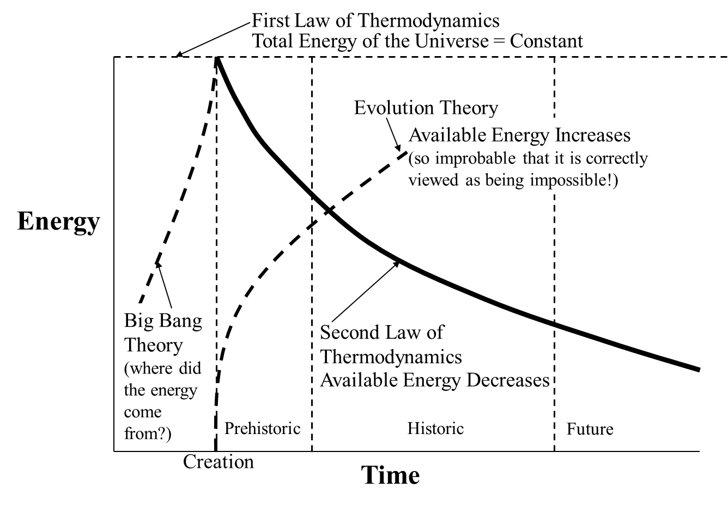
Figure 8-12 Comparison of the creationist cosmogony model given in Figure 8-9 (consistent with the laws of thermodynamics) with the evolution/big bang cosmogony which is based on non-observable processes which are not consistent with the laws of thermodynamics. The incorrect theories are indicated with dashed-lines on the figure. Big bang theory cannot provide any explanation for where the energy came from. The creation theory provides a clear explanation for the energy source—God is the source of the energy for creation.
explain where the so called ‘cosmic egg’ came from, it is at best an incomplete and unsatisfying theory. Of course, the creationist argues that the source of energy for creation was God, and He is separate from, and transcends, the created universe. Figure 8-12 also illustrates the violation of the second law after the creation of the physical universe. The theory of evolution would require an unimaginably large amount of organization, which would somehow add available energy to the cosmos, in contrast to the currently observed available energy decrease over time under the second law.
As in the case of the second law, the Bible contains a number of passages that affirm the first law. These scriptures are not couched in the scientific jargon of our modern era, but rather are expressed in terms of the timeless concepts that God has revealed. Passages that assert God resting from a finished creation are seen in—Gen 2:1-3, Ex 20:11, Ex 31:17, Heb 4:3-4, and Heb 4:10. In addition to these passages, there are a large number of texts which refer to God’s works of creation all being in the past (for example, Col 1:16). Thus, the Bible always refers to the creation of the universe, and all living things, as a past event that is not continuing today. As seen in Figure 8-9, this is consistent with the thermodynamic model. Passages showing God’s preservation of the finished creation are found in—Neh 9:6, Ps 148:6, Col 1:17, Heb 1:3, Jas 1:17, and 2 Pet 3:7. Scriptural texts which assert permanence of the created kind of organisms are found in—Gen 1:11, Gen 1:21, Gen 1:25, 1 Cor 15:37-39, and Jas 3:12. Finally, passages affirming both completion and permanence are found in—Eccles 1:9-10, Eccles 3:14-15, and Is 40:12.

Desiring God post (Facebook, March 25, 2018), by John Piper.
Millard J. Erickson, Christian Theology (Grand Rapids: Baker Academic, 1998), 392-394.
The book's full original title was On the Origin of Species by Means of Natural Selection, or the Preservation of Favored Races in the Struggle for Life. In the 1872 sixth edition, "On" was omitted, so the full title is The origin of species by means of natural selection, or the preservation of favored races in the struggle for life. This edition is usually known as The Origin of Species. The 6th is Darwin's final edition; there were minor modifications in the text of certain subsequent issues. See Freeman, R. B. "The works of Charles Darwin: an annotated bibliographical handlist."
https://www.glencairnmuseum.org/newsletter/2021/7/13/ancient-egyptian-creation-myths-from-watery-chaos-to-cosmic-egg+
Isaac Asimov, “In the Game of Energy and Thermodynamics, You Can’t Even Break Even,” Smithsonian Institute Journal, (1970): 6.
Duane Gish made this statement during a formal debate against Ken Saladin, which took place on March 20, 1988, at Auburn University in Alabama. https://infidels.org/library/modern/ken-saladin-saladin-gish2-gish1/#:~:text=We%20have%2030%20trillion%20cells,is%20from%20this%20hydrogen%20gas.

